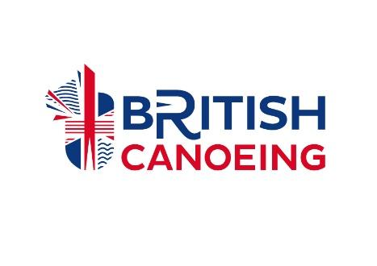
BRITISH CANOEING
PARACANOE CLASSIFICATION APPLICATION FORM
First Names |  |  | Surname
Gender |  |  | Date of Birth
Nationality

Full Home Address including Postcode
Contact Telephone Number
Email address
British Canoeing Membership number (if applicable)
Club Name

Please state your diagnosis and any associated diagnoses:

Have you had surgery within the last two years? YES / NO
If yes, please give date(s) of any surgery, a brief overview and the consultant’s discharge date:

If you have applied for classification in a second impairment type, please provide details of the impairment type, organisation and date of application:

Explanation: For a paddler to be eligible to compete in British Canoeing (BC) Paracanoe events, the paddler must be classified under the BC Classification rules and regulations for Paracanoe. Failure to cooperate with the Classifiers or failure to complete the classification procedure will lead to ineligibility to compete in BC Paracanoe competitions.
The classification process will be conducted with all due care to limit any discomfort to individual paddlers. However, failure to complete the classification process, regardless of discomfort, will result in the paddler not being classified and therefore not being eligible to compete. The paddler may withdraw their consent at any time but the process will then not be undertaken and the paddler will not be classified.
By signing this consent form, the paddler agrees to waive their rights to make any claim against the Classifiers, BC or anyone who might then claim against the Classifiers or the BC for indemnification for any damages or claims of personal injury or any other claim arising from or in any way related to the classification procedure of the paddler. The paddler agrees to fully indemnify BC and the Classifiers should any claim be made against them in any way related to the classification of the paddler.
The following is an agreement by the paddler, and the paddler’s parent/legal guardian where appropriate; consenting that the paddle agrees to fully participate in the BC Paracanoe eligibility criteria and classification procedure. The BC will only use the information for the administration of Paracanoe classification, in accordance with International Paralymic Committee (IPC) rules. By signing below, the paddler agrees to complete the test honestly to the best of their ability.
Data Protection: This form should be sent directly to British Canoeing at classification@britishcanoeing.org.uk. British Canoeing is a privacy conscious organisation and is strongly committed to an individual’s right to privacy. All data gathered during the completion of this form will only be utilised for the purposes specified. This will include administering your classification application and progression to allocation of classes and classification status. Your personal data will be shared with British Canoeing accredited classifiers. Should you be identified for an international classification, the data provided may also be shared with the International Paralympic Committee (IPC) and British Paralympic Association (BPA), but solely for the purposes of international classification procedures.
Any personal data will be processed and stored in compliance with the British Canoeing Data Protection Policy and in accordance with all applicable Data Protection laws in effect at the time of publication of this form, including but not limited to, the Data Protection Act 2018 and the GDPR which came into effect on 25th May 2018.
Further information on British Canoeing’s approach to privacy and data protection, including our privacy notices, policies, and contact details, can be located in our Privacy Centre (https://www.britishcanoeing.org.uk/about/privacy-centre). Should an athlete wish any data British Canoeing hold relating to them to be deleted at any point, they should contact British Canoeing at GDPR@britishcanoeing.org.uk. In the event that there is a change to your personal information, please let us know as soon as possible, in writing, in order that we can keep your information up to date and accurate. By signing below you are confirming that you consent for your personal data to be processed and stored as described above.
Athlete Name |  | Date
Athlete Signature
Where the athlete is under 18:
Parent/Guardian Name |  | Date
Parent/Guardian Signature

Witness Name |  | Date
Witness Signature

Please send your completed form to classification@britishcanoeing.org.uk

