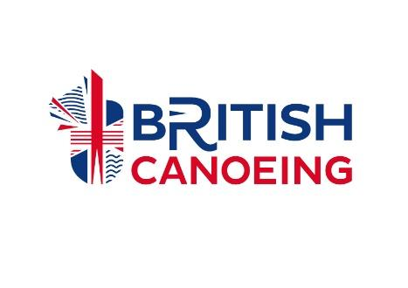
BRITISH CANOEING
PARACANOE MEDICAL DIAGNOSES FORM
First Names |  |  | Surname
Gender |  |  | Date of Birth
Athlete’s Signature

Medical Details (this section must only be completed by a medical doctor)
Athlete Diagnosis:

How long has the athlete had this condition?
Is the condition: STABLE DETERIORATING FLUCTUATING
(please circle one)
Are there any other factors which may affect the athlete’s fitness for competition? E.g. epilepsy, diabetes, heart disease, cancer, severe allergies, high blood pressure:

Declaration
I hereby certify that I have known this patient for years and certify that the above named patient has the stated diagnosis.
I hereby certify that this athlete is fit to compete in Paracanoe competition 🗌 (please tick)
Doctor’s Name |  | Date
Doctor’s Signature

Address of Medical Practice

Doctor’ Email

Doctor’s Telephone Number
Practice Stamp

Please send your completed form to classification@britishcanoeing.org.uk

