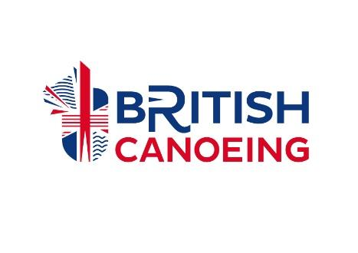
BRITISH CANOEING
DECLARATION OF MEDICAL COMPLICATIONS & EMERGENCY MEASURES
I, , wish to compete in BC Paracanoe events.
(please print full name)

I understand that the BC requires me to state any known medical conditions that may compromise my safety on the water. I understand that I must state the current management for my condition(s).
Possible Medical Complications:

Steps to take should these occur:

All medication is as follows:

Athlete Name |  | Date
Athlete Signature

Where the athlete is under 18:
Parent/Guardian Name |  | Date
Parent/Guardian Signature

Witness Name |  | Date
Witness Signature

Please send your completed form to classification@britishcanoeing.org.uk

