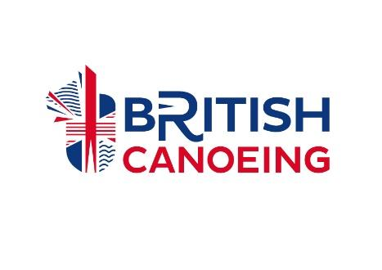

BRITISH CANOEING
PARACANOE REQUEST FOR CLASSIFICATION REVIEW
A Review request is possible for paddlers with a status NC or NRFD, when it is considered that there is a change in the paddler’s medical condition that would affect the classes allocated:
- By the paddler/parent/coach if the paddler’s medical condition have changed either by medical intervention or other
- By paddler/parent/coach where the paddler’s impairment is progressive and have deteriorated significantly that the paddler may not fit the current classes
- By the Classification Committee if the classification system is revised/modified

The outcome of a review request may be one of the following:
- There is evidence to support a review and a review will take place the earliest opportunity
- The request is declined and no review is granted
- Further medical evidence is requested for consideration

Please note:
- Recent (within the last 12 months) and relevant medical documentation must be included with this request
- Request for reviews must be submitted to British Canoeing at least 3 months prior to the commencement of the competition where classification is available

First Names |  |  | Surname
Gender |  |  | Date of Birth
British Canoeing Membership number (if applicable)

British Canoeing Classification: KL1 KL2 KL3 VL1 VL2 VL3
(please circle one)
Classification Status: NC NRFD
(please circle one)
Reason for Review: Change in Medical condition 🗌 Change in classification system 🗌
(please tick one)
Description of the change in impairment (for progressive impairments, injuries) and/or details and dates of any intervention (to be completed by a health professional with relevant expertise):

Medical documentation in support of the request attached form:

Name of the person submitting the request |  | Date
Relationship to Paddler
Signature

FOR OFFICE USE
Date Classification request Received
Classification request received by (print name)
Signature |  |  | Position

Request Accepted 🗌 Request Denied 🗌

Reason for denial:

