2nd 3rd June 2018 – Paddle In The Park
Event Plan
VENUE
White Water Centre – Lagoon
Holme Pierrepont
Adbolton Lane
West Bridgford
Nottingham
NG12 2LU

SUMMARY
Friday 1st June 2018
11:00-14:00 Set up Gazebos and signage On site - HPP
13:00-14:00 Mark out trade partners stands Demo lake
Saturday 2nd June 2018
07:00-08:30 Staff Arrival & Trade set up Lagoon/White Water demo
08:30 -09:15 Staff Briefing Staff room –next to wetsuits
09:45 – 17:00 Registration opens By the lagoon reception
10:00 – 12:00 First workshops White Water Course
13:00-15:00 Second round of workshops White Water Course
15:30-17:00 Final round of workshops White Water Course
17:30 – 18:30 Boater X Competition White Water Course
Sunday 3rd June 2018
08:00 – 08:30 Staff Arrival Lagoon/White Water demo
08:30 -09:15 Staff Briefing Staff room –next to wetsuits
09:45 – 16:00 Registration opens By the lagoon reception
10:00 – 12:00 First workshops White Water Course
11:00 – 14:00 National Freestyle League Competition White Water Course
13:00-15:00 Final round of workshops White Water Course
13:00 – 15:00 SUPX Heats for competition White Water Course
15:00 – 16:30 SUPX Competition and finals White Water Course
Please take note of all workshops and competitions taking place at the same time as you. Please be considerate of other paddlers and share the space.
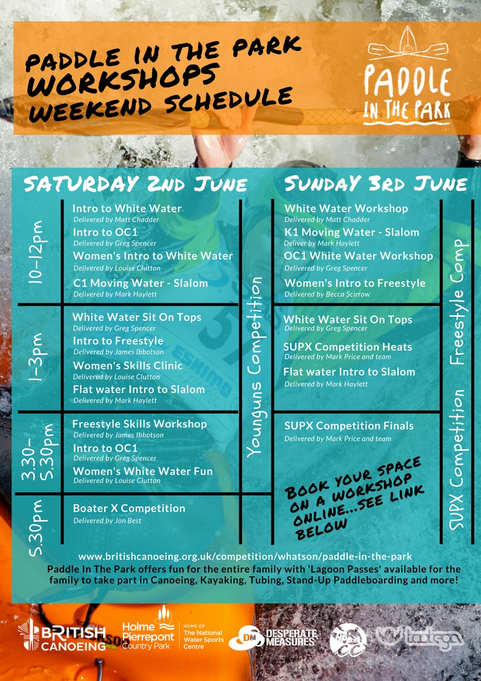

Trade stands
Tootega/Silverbirch
Red Paddle
Dagger
Zet
Palm
Naish
Peak
Jackson
Pyranha
Wavesport
NRS - David Bain
REGISTRATION –
There will be 2x registration gazebos – One on the left for White Water Passes and Workshops and then one of the right for the Lagoon Pass.
Registration desk – Saturday 2nd
Phil, Craig, Kellie, Laura P and Libby/Laura (Libby from 10-12/1pm) – 1 member of staff from Serco
British Canoeing Gazebo
Women’s Ambassadors, Jenny & Libby/Laura (floating)
Registration desk – Sunday 3rd
Phil, Craig, Russ, Laura P and 1 member of staff from Serco
British Canoeing Gazebo
Women’s Ambassadors, Jenny & Laura (floating)
Goodie Bags for workshops contain:
- Membership leaflets
- Go Canoeing booklet/leaflet
- Coaching leaflet
- National Go Canoeing week leaflet
- Three lakes leaflet
- Holme Pierrepont Leaflet
- Keyring
- Pen
- Poncho
Goodie Bags for lagoon pass include:
- Membership leaflets
- Go Canoeing booklet/leaflet
- Coaching leaflet
- National Go Canoeing week leaflet
- Holme Pierrepont Leaflet
- Poncho
Workshop Information:
Workshops are pre-booked, but there will be some spaces on the day. Those looking for these spaces will need to come to
Sign in for White Water Pass and Workshops will be separate to the Lagoon Pass.
Those accessing the white water will not be allowed on without the coloured wristband for a white water pass and/or the workshop coloured wristband.
Workshop meeting points:
Workshop participants should meet at the ‘Workshop Meeting Point’ about 10 to 15 mins before the workshop start time to meet their workshop deliverer. This is located by the British Canoeing information tent.
Workshop leaders: PLEASE KEEP YOUR MOBILE ON YOU AT ALL TIMES AND SAVE CONTACT NUMBERS BELOW IN CASE OF EMERGENCY OR CALL FOR HELP.
Please take note of all workshops and competitions taking place at the same time as you. Please be considerate of other paddlers and share the space.

Site Map:
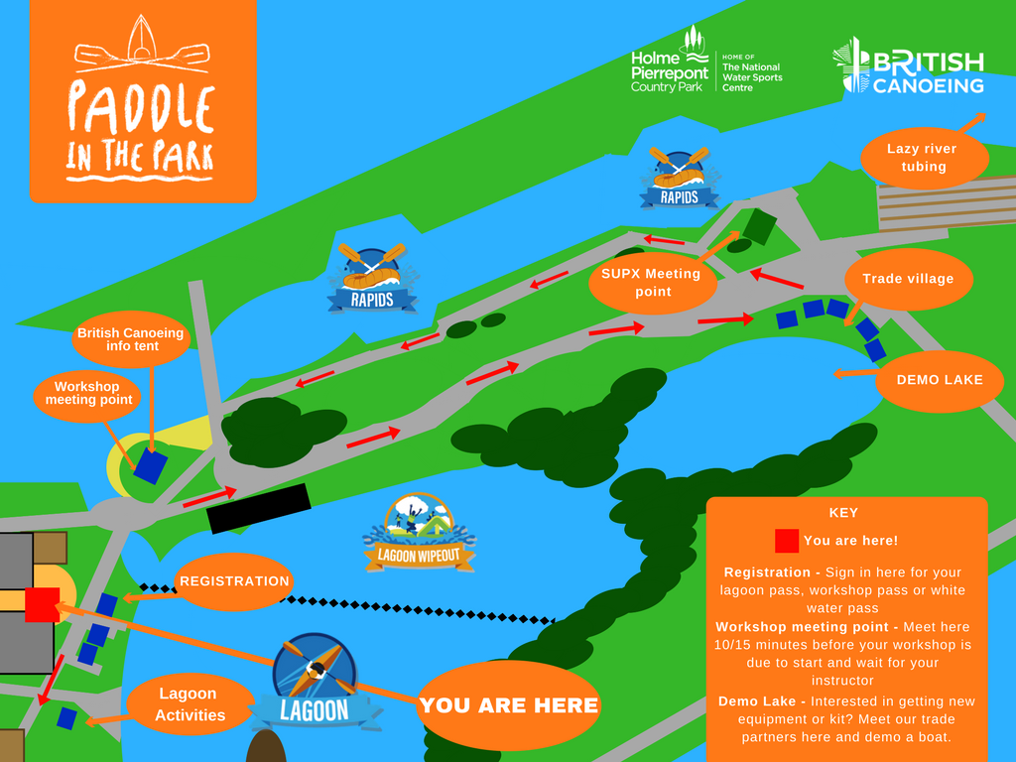

Safety on Site:
- Wristband system – Please all be aware of the wristband system throughout the weekend
Red wristband = Lagoon Pass
Blue Wristband = White Water Pass
Purple Wristband = Workshop pass (only for their allotted time – if they would like to stay on the white water, they must buy a white water pass)
All bands will have the day written on e.g. SAT or SUN or FULL WEEKEND.
If they only have SAT on, then they have only paid for Saturday etc.
The bands are to be worn on the left arm of buoyancy aid or the wrist.
BANDS MUST BE CHECKED BEFORE GETTING ON THE WHITE WATER – ALL STAFF ARE RESPONSIBLE FOR CHECKING OUT OF DATE BANDS AND CORRECT COLOUR BANDS
- White Water Safety – All participants will have signed to declare they are competent on white water if paddling by themselves. All should be able to perform a roll and self-rescue. Those on a workshop may not be able to roll, but will be under the guidance of qualified/experienced leaders.
- Weather – Lead event staff to monitor weather and decide when event needs to be modified. E.g. Gazebos to be brought down in high winds, Participants asked to get off the water in risky conditions.
- Lightening Policy – To be controlled by Serco/Holme Pierrepont Country Park staff – Lightning 30/30 rule: If it takes less than 30 seconds to hear thunder after seeing the flash, lightning is near enough to pose a threat; after the storm ends, wait 30 minutes before resuming outdoor activities.
- Gazebos/Event structures – ALL EVENT GAZEBOS/TENTS MUST BE WEIGHTED AND PEGGED DOWN.
- White Water Rafting – To be considerate of white water paddlers when coming down the course. White water paddlers to move to one side/to eddies when a raft is coming down the course.
- Spectators – All staff to be aware of spectators and ask that no one steps over the barriers/edges and gets too near to the water.
- White Water Rescue – To be provided by the centre – Serco/Holme Pierrepoint for the duration of the event.
- First Aid – To be provided by the centre – centre staff. Lead contact for First Aid is: Scott Harrand – White water course number is 01159821212 ext 24712
Trade Village/Demo Lake:
- All demo staff to follow the wristband policy.
- Anyone with a lagoon pass wristband wanting to demo a boat will need to be supervised as they have not signed a competency form.
- Those with White Water bands and workshops bands are more able to demo independently.
- All demo activities are the responsibility of the trade supplying the boat to demo.

Risk Assessment: PADDLE IN THE PARK | Date: 31st May 2018 | Carried out by: L Sutherland

WHITE WATER COURSE – Workshops and White Water Paddlers
Hazard | Who might be harmed and how? | Before Controls (initial risk) | Control Measures (Existing) | Control Measures (Proposed) | After Controls (Revised risk)
 |  | 1-5 |  |  | 1-5
Local Rules | White Water Participants | 2 | - Participants to sign in and register before getting on the water.  - Coaches are to walk the course prior to starting the session-this can be undertaken whilst setting a course | - Participants must be wearing a White Water Wristband to access the white water. | 1
Course Configuration | Leaders/Participants and competitors | 2 | - Coaches/leaders are to highlight any potential hazards/risks to their participants for their session | - Leaders and Competition leads to walk the course and highlight any hazards during briefings. | 2
Entrapment | Leaders/Participants and competitors | 2 | - Participants are made aware of the hazards  - Centre to set a safe course  - Centre is to ensure that safety equipment is available throughout the session | - All participants on white water declared able to self-rescue and are competent swimmers.  - Leaders able to rescue  - White Water safety staff on stations throughout the course. | 1
Moving Water | Leaders/Participants and competitors/Spectators | 3 | - Participants made aware of the hazards  - Participants aware of good swimming techniques in moving water  - Leaders and participants to wear a buoyancy aid at all times when operating water side of the step  - Spectators not allowed water side of the step | - All participants on white water declared able to self-rescue and are competent swimmers.  - Coloured band system will not allow Lagoon Pass holders to access the white water.  - Buoys across the bridge area to the white water course to stop beginners floating towards the white water. | 2
Other Users on the course | Leaders/Participants and competitors | 2 | - Leader to co-ordinate usage with other users  - All users to be aware of participants on the White Water Course  - Participants to understand Course Etiquette and always look upstream before leaving the eddy | - Leaders of workshops to inform groups. | 1
Slalom Poles | Leaders/Participants and competitors/Spectators | 1 | - All excess poles to be pulled to the side before the session by the centre and competition staff. |  | 1
Slippery Banks | Leaders/Participants and competitors | 3 | - Participants and leaders to be aware of the hazards | - Event staff to monitor this and use signage to warn if needed. | 2
Setting the Course | Leaders/Participants and competitors | 1 | - Good manual handling techniques are to be used at all times  - Buoyancy Aid to be worn at all times |  | 1
Emptying Boats | Leaders/Participants and competitors | 2 | - Good manual handling techniques are to be used at all times  - Leaders to support workshops | - Pay and play participants to have help on the bank with kit and equipment. | 1
Equipment and Clothing | Leaders/Participants and competitors |  | - Leader is to ensure that the clean rope/line theory is applied at all times  - Suitable equipment to be worn at all times | - Wetsuits, helmets and buoyancy aids available for all to rent or borrow. | 1
Head Injuries, Fractures, Dislocates | Leaders/Participants and competitors | 2 | - Report any injuries to reception and complete an Accident Report Form  - First aiders provided by the centre | - Create a clear process for major accidents | 1

ON SITE RISK ASSESSMENT – Including spectators, participants, demo area, registration and trade stands.
Hazard | Who might be harmed and how? |  | Before Controls (initial risk) | Control Measures (Existing) | Control Measures (Proposed) |  | After Controls (Revised risk)
 |  |  | 1-5 |  |  |  | 1-5
Falling equipment or gazebos | Participants, Staff |  | 3 | - All structures to be weighted and pegged down to the ground.  - Signs to be hammered into ground. | - If weather conditions worsen, e.g. Wind speed – Gazebos and tents to be deflated/taken down. |  | 2
Dehydration/tiredness | Participants, Staff, Leaders |  | 2 | - All encouraged to keep hydrated throughout the day | - Water in the staff/volunteers room for all |  | 1
Trip Hazards | Leaders/Participants and spectators | 2 |  | - Any trip hazards reported to main reception.  - Spectators stay behind the bank step. | - Wires or leads to be covered/taped down | 1
Score | Overall Risk | Acceptability
1 - 2 | Low risk | Reasonably acceptable risk. Modify wherever possible. Implement control measures. Monitor.
3 | Medium risk | Tolerable risk. Review and modify wherever possible. Enforce control measures. Review regularly. Monitor.
4-5 | Very High risk | Unacceptable risk. Stop work and modify urgently. Enforce control measures.

EVENT MAJOR INCIDENT – RESPONSE PLAN
ACTIONS

P  R  O  T  E  C  T  L  I  F  E | Effect rescue.  Protect individual/s from further harm. Ensure you and others are safe
 | Administer emergency First Aid
 | Clear the water of boats as necessary, while the incident is ongoing
 | Evacuate premises as necessary
 | If lives are at risk or there is serious injury call the emergency services by calling 999. Tell them what the problem is, your location, how many are involved, when it happened

T  A  K  E  C  O  N  T  R  O  L | Nominate/appoint a lead person to coordinate the incident response.  Usually the Event Organiser, Safety Officer, Coach or senior club member.
 | Share the load and nominate others, officials or volunteers to undertake roles to help manage the incident.
Establish facts/sequence of events.
Record the witnesses details of those involved in the incident/rescue.
Take notes and record the actions taken.

 | Photograph the incident location, boats or equipment etc if relevant
 | Protect welfare of others. If children are involved contact Parents at an early stage

N.B If the Emergency Services are called they will take control.
In the case of a fatality the Police will notify the next of kin.

I  N  F  O  R  M | Notify the emergency services of all the details available
 | Determine whether you need to contact other agencies e.g. Local Authority, Environment Agency, Harbour Master/Port Authority, electricity/Gas etc
Prepare to receive enquiries.
Sensitively brief relevant staff/volunteers and other club members.
Remind people not to pass on any names until given permission to do so.

 | If the incident involved a work related fatality or major injury it must be reported to the Health and Safety Executive under RIDDOR.
Complete a British Canoeing Incident report form
https://www.britishcanoeing.org.uk/about-canoeing/safety-guidance/incident-reporting/

M  E  D  I  A | If you are contacted by the media, find out more details about their request and timescales.
 | Support their request by issuing a written statement from a nominated “spokesperson”.
If asked for an interview, nominate one person as the designated spokesperson and prepare a statement that can be read out
Have another person with you if possible to monitor the interview.

Do not give the names of casualties or those involved in the incident.
Make sure your key facts are up to date and to hand.

Do not give an opinion
Stick to the facts as you know them, do not try and answer a question you don’t know the answer to.
In any media responses follow: Pity, Praise, Promise: -
Pity – express sympathy for those caught up in the incident
Praise – those who undertook a rescue or tackled the problem i.e. emergency services, paddlers etc
Promise – to participate fully in any investigation and learn from it to minimise the risk of it ever happening again

If there incident is a police matter you will receive support from your local constabulary.
If you require any assistance or advice contact the British Canoeing communications team at mediaenquiries@britishcanoeing.org.uk

F  O  L  L  O  W  U  P | Contact safety@britishcanoeing.org.uk for ongoing support.
 | Retain a log of the incident
 | Arrange a debrief for staff/volunteers and consider their welfare needs
 | Use information gained from the incident and debrief to update Risk Assessments and local emergency action plans
 | Ensure that any documentation pertaining to the event or incident is collated and available for any further investigation or analysis e.g. Risk Assessments, operating procedures, event information issued to participants, coaching qualifications status etc

Contact numbers:
Laura Sutherland – Events Officer – British Canoeing – Phone number
Scott Harrand – Chief Instructor – Phone number
Harriet Taylor – Events Officer – Serco/Holme Pierrepont – Phone number
Jenny Spencer – Go Canoeing Development Manager - Phone number

